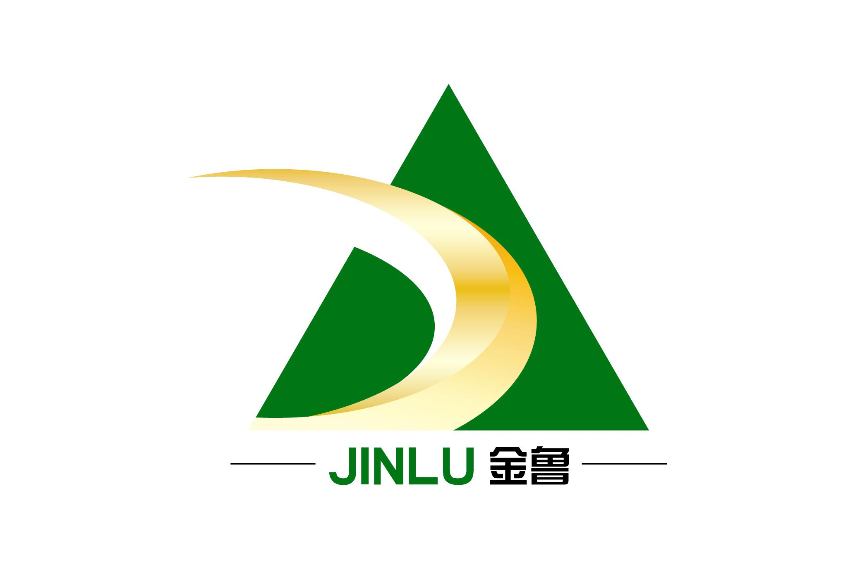
JINLU BIO-TECHNOLOGY INC
_________________________________________

MATERIAL SAFETY DATA SHEET
Section 1: Chemical Identification and Company Information
English Name: Fixing agent for nylon JL-O
Company Name : SHANDONG JINLU BIO-TECHNOLOGY INC
Post Code: 255300
Email: jinluranliao@163.com
Fax:86-533-6821999
Emergency Company Tel:86-533-6821888

Section 2: Ingredient /Component Part Information
Components: Condensed polymer of alkyl aromatic sulfonic acid derivatives
Section 3: Hazard overview:
Hazardous Class: There is no “Dangerous Goods” Mark and No. in the above chemical product .
The Incursive Way: Don’t eat.
Health Hazard: If you eat it by mistake, it is harmful to your healthy.
Environmental hazard: None
Blasting Risk: None
Section 4: First Aid Measures:
Skin contact: Putting off the polluted clothes, and Rinsing the skin with a lot of flowing water.
Eye contact: Filed eyelid, rinsing it with a lot of flowing water or physiological saltwater.
Inhalation: Go to the place where have fresh air immediately. If you have difficulty in breathing, please inputting the oxygen. And go to the hospital.
Ingestion: Drink sufficient quantity of water, vomit. Go to the hospital.

Section 5: Fire Fighting Measures
Hazardous Properties: incombustible, inexplosive, Nontoxic
Harmful Combustion Products: None

Section 6: Accidental Release Measures
Emergency processing measures: Isolating the leakage polluted area, changing the package, scouring the ground. Collecting and recycling or transported to waste disposal sites, then disposing it.

Section 7: Handling and storage:
Handling Notes: The operator must be specially trained, to comply with working specifications strictly. Advising the operator wear a mask ,chemical safety glasses , personal proactive clothing and rubber gloves. No smoking in working place. Using the explosion-proof type ventilation system and equipment. Avoid being touched with oxidizing agent. When removing, lightly loading and unloading, to prevent the damage of the package and container. Fitting out corresponded leakage emergency equipments.
Storage Notes: Keeping them in cool and shady, ventilation storage house. Separate storing them from oxidizing agent, never mixing with other materials. There should be the suitable apparatus for leaked materials in storage house.

Section 8:Contact controls/ Personal Protection
Engineering Control: Closure in produced process, enhance ventilation.
Respiratory Protection: Wearing a mask
Eye Protection: Wearing chemical safety glasses
Body Protection: Wearing personal protective clothing
Hand Protection: Wearing rubber gloves
Other Protections: Washing your clothes in time. Keep good hygienic habits.

Section 9: Physical and Chemical properties:
Appearance: Red-brown clear liquid.
Ionic Nature: Anionic
PH： 2.5-3.5
Viscosity： 700-2000mpa.s
Main Usage: It is applied in the after-finishing process.

Section 10: Stability:
Stability: stable
Hazardous Reflect: None
Hazardous Decomposition Products: None

Section 11: Toxicological Information
Toxicity: None
Incipient Skin Irritation: Non-irritating
The initial issuance of mucous membrane irritation: Non-irritating

Section 12: Ecological Information
Environmental Influence: In the rat experiments, there is no retention in the body during the late period after inbreathing 300ppm.
Evaluation Of Aquatic Toxicity: So far, as we know, no adverse impact to ecological environment.

Section 13: Disposal Considerations:
Disposal of Waste Methods: In accordance with the local government rules, Dumping them at the garbage dump or setting on fire, the uncontaminated packing can be recycled.

Section 14: Transport Information
Package Class: Generally plastic drum packing, Specification: 125kg.
Transport Notes: The package should be complete before shipment, and the loading should be safe. During the transporting, making the container not leak, not fall, not crash, not damage, and avoiding high temperature.

Section 15: Regulatory Information
Regulatory information: Chemical hazardous goods management ordinance(Promulgated by the state council ,17th,Feb,1987), Chemical hazardous goods management ordinance implementing Rules( Promulgated by Chemical Labor,1992,No.677),The rules of safe using chemical products in workplace(Promulgated by the Lavor,1996,No.423),this product does not need hazard warning labels.

Section 16 :Other Information:
About Specified Usage Information: This product is used in the craft of the textile after-finishing. Except otherwise stated or appointed usage , it is only used in industry. It include the mentioned and recommended usage, If you plan to use it in others usage, you should talk with supplier. Especially when the usage of product is controlled by special standard and ordinance, you should discuss with the supplier.

GHI CHÚ: Giat để nhuộm lại

The effects obtained by after treating with Nylofix-993 are stable to dry heat at the usual setting temperatures, but can be impaired by intense pressure steaming. Increasing the amount of Nylofix-993 will often improve the stability of the dyefixation to steaming. Polyamide material treated with Nylofix-993 is difficult to re-dye or over-dye. Nylofix-993 should therefore be stripped first before re-dyeing.
Removal of Nylofix-993 from a substrate
2 g/l ammonia 24%
2-3 g/l detergent
Run for 10-20 minutes at 80-90 deg.C followed by rinsing.
Preservation:
It is recommended to add 0.1% Bronopol (2-Bromo, 2-nitropropane, Paraben (methyl para hydroxy benzoate) as an antimicrobial agent to avoid fungal/microbial growth.

